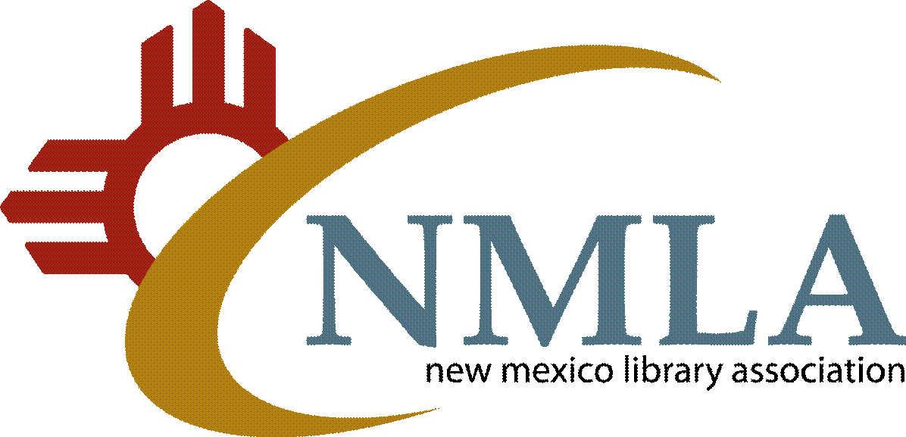

(505) 400-7309 - Phone P.O. Box 26074, Albuquerque, NM 87125 (505) 891-5171 – Fax
www.NMLA.org

NEWSLETTER ADVERTISING INSERTION ORDER

Company Name
Address
City/State/Zip
Contact Name
Phone # |  | Fax #
E-Mail

Please send ad copy electronically to newsletter@nmla.org.

AD SIZE | SINGLE ISSUE | SIX ISSUES
Full Page (7½ x 10") | _____ $250 | _____ $950
Half Page - Horizontal (7½ x 5") | _____ $150 | _____ $550
Half Page - Vertical (3¾ x 10") | _____ $150 | _____ $550
Fourth Page (3¾ x 5") | _____ $ 75 | _____ $300
Business Card | _____ $ 20 | _____ $100

Please mail this form with a check or purchase order or charge by credit card online at https://nmla.wildapricot.org/.

